 if( JsonData!=null && jsondata.value.length>0 && jsonData.value[0]!=null)

    {

    discountcodeid = jsonData.value[0].cmc_discountcodeid;

    }

**API** is an interface that allows you to build on the data and functionality of another application, while a **web service** is a netw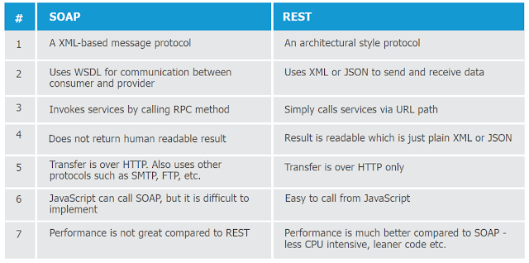ork-based resource that communicating with each other via the World Wide Web,

[used for exchanging data between systems or application via web

**API vs Micro Services:**

**Microservices** are an architectural style for web applications, where the functionality is divided up across small web services. ... whereas. **APIs** are the frameworks through which developers can interact **with a** web application

An **API** is a part of a web application that communicates with other applications. ... A **microservice** is an approach to building an application that breaks down an application's functions into modular, self-contained programs. **Microservices** make it easier to create **and** maintain software

definitely an overlap between the two, since so many microservices use APIs to communicate between themselves.

What’s a Microservice?

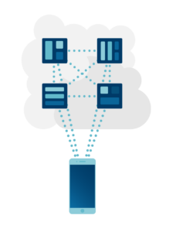The microservice architecture was envisioned in part to solve the underlying issues of a centralized monolith approach. Simply put, microservices are **distributed**. A core problem underlying the monolith approach is that everything is centralized, and as such, the choice to adopt microservices is essentially an opposite path. Microservices are a collection of small services, each developed as its own segment as part of a collective group of services. A microservice may be self-contained, but it typically functions as one of **many services** that make up the overall core process.

One way to think about microservices architecture is

**Monolithic architecture** is built as one large system and is usually one code-base

. **Microservices architecture** is built as small independent module based on business

**Microservice** Architecture is an architectural development style that allows building applications as a collection of small autonomous services developed for a business domain. ... In this **Microservices** architecture **example**, each **microservice** is focused on single business capability

## Microservice Advantages

The primary benefit of a microservice approach is that the cost for deployment, development

**Deploying elements in pieces rather than as one** whole brings many practical positive effects.

First off, microservices **isolate bugs**. Since services are segmented by design, bugs will only affect a single part of the codebase

Pros: **microservices**

**Better insights:**API gateways can collect statistics and metrics about the usage of various

**Cons: microservices**

**Cross-cutting concerns:**In the microservices architecture, cross-cutting concerns such as logging, caching, and performance monitoring are more difficult to deal with, due to the complex web of connections between each microservice

## Monolith Disadvantages

## Monolith means composed all in one piece. The Monolithic application describes a single-tiered software application in which different components combined into a single program from a single platform. ... Application integration — integration with other services (e.g. via messaging or REST API).02-May-2018

 it quickly becomes too top-heavy, requiring more resources and effort to manage the core functionality.

\**scalability suffers** as complexity grows. Scaling a monolith is basically “throw more resources at the problem and load balance the result,

**Pros: Monolith**

* **Ease of use:**Monolithic software applications have many different functionalities contained within a single application, including logging, caching, and performance monitoring. This makes it easier to handle, and for other components and applications to connect to it.
* **Development:**For most developers, building monolithic software applications is easier and more familiar. Because monolithic software applications act as a single unit without architectural complexity, it’s relatively less difficult to debug and test them.
* **Performance:** In certain use cases, monolithic software applications may be faster than microservices. Accessing shared memory, as occurs with monolithic applications, is typically faster than inter-process communication (IPC).

AzureDevops:

 collaboration between development and operations teams in an organization.

Basically, DevOps increases the speed of processes for the delivery of applications and software services at higher velocity. The continuous delivery aspect in DevOps also ensures the minimization of the risk factor through collecting stakeholder and end-user feedback.

Azure DevOps is the new name for Microsoft Visual Studio Team Services (VSTS).

Azure DevOps also helps in the deployment of a solution across different platforms by leveraging Azure Pipelines

### **What is the difference between Azure DevOps Services and Azure DevOps Server?**

Candidates would generally face this entry as one of the tricky Azure DevOps interview questions. Azure DevOps Services is the cloud service of Microsoft Azure with a highly scalable, reliable, and globally available hosted service. On the other hand, DevOps Server is an on-premises offering, built on a SQL Server back end.

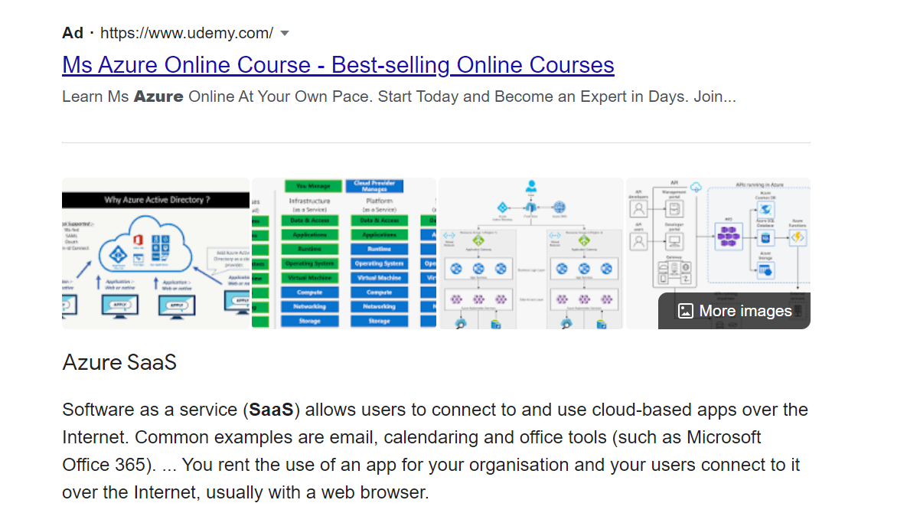

**What are the different types of OAuth grant types?**

The most common OAuth 2.0 grant types are listed below

. Authorization Code

Implicit.

Password.

Client Credentials.

Device Code.

Refresh Token

Groovy scripts:

**How could you retrieve a single value from data base using Groovy?**

To recover a single value from the database you can use the command

row = sql.firstRow ('select columnA, column from tableName')

println "Row: columnA = $ {row.columnA} and column = ${row.columnB}"

DB connection using Groovy

import groovy.sql.sql

sql = Sql.newInstance ('jdbc: jtds: sqlserver://serverName/dbName-Class;domain=domainName','username','password','net.sourceforge.jtds.jdbc.driver')

sql.eachRow ('select * from tableName') {print "$it.id--${it.firstName} –"  }

**19) Explain the role of Grape dependency in Groovy?**

Grape is a JAR dependency manager included into Groovy.  It allows you to add quickly maven repository dependencies to your classpath, making scripting easier. The simplest use is adding an annotation to your script.

**20) Explain what does the JsonSlurper class indicates?**

The JsonSlurper is a class that parses JSON text or reader content into Groovy data structures (objects) such as lists, maps, and primitive types like double, Boolean, string and Integer.

import groovy.json.JsonSlurper

def jsonSlurper = new JsonSlurper();

def response = jsonSlurper.parseText(prev.getResponseDataAsString());

vars.put("accountId_BSH", response.accountId.toString());

**21) When "propertyMissing (String)" method is called?**

The "propertyMissing (String)" method is called when no getter method for a given property can be detected by the Groovy runtime.

**22)Global varaible**

vars.put("GetSurveyResponseData", prev.getResponseDataAsString());

get variable:

String responseData=vars.get('GetSurveyResponseData');

String convertedData = responseData.toJSONString().replace(""","\"");

#### List down some of the advantages of Groovy.

As Groovy is an object-oriented programming language used for JVM, it is quite useful. Advantages of groovy are provided below:

Its syntax is similar to the Java language syntax.

* Because it is based on Java, so it has access to a rich collection of Java libraries.
* It is fully object-oriented.
* It can be easily integrated with the existing interface.
* Groovy code is reusable and assignable.
* Groovy supports operator overloading.
* With Groovy’s declaration of Maps, arrays, ranges, and regular expressions are possible.
* It ensures efficient navigation of objects.

#### **What different components are used in Web Services?**

Answer: Five components:

* WSDL – Web Service Description Language
* UDDI – Universal Description, Discovery, and Integration
* SOAP – Simple Access Object Protocol
* XML – eXtensible Markup Language
* RDF – Resource Description Framework

#### **What are some Assertions used in SoapUI?**

Answer :

* API Testing Interview Questions
* Script Assertion
* WS- Addressing Request or Response Assertion
* WS security Status
* Soap Faults
* Response SLA
* Schema compliance
* XPath match
* XQuery match
* Contains & Not Contains

#### **What data sources are used for SoapUI?**

* Excel files
* ODBC sources
* CSV files
* SQL or ADO objects

Test Plan:

1. Analyze the product
2. Design the Test Strategy
3. Define the Test Objectives
4. Define Test Criteria
5. Resource Planning
6. Plan Test Environment
7. Schedule & Estimation
8. Determine Test Deliverables

SDLC VS STLC:

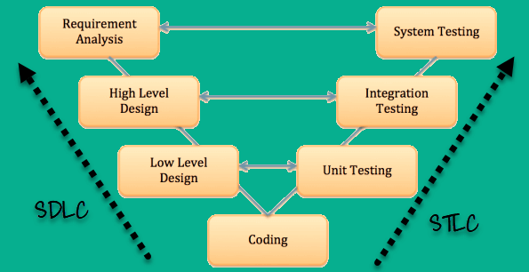

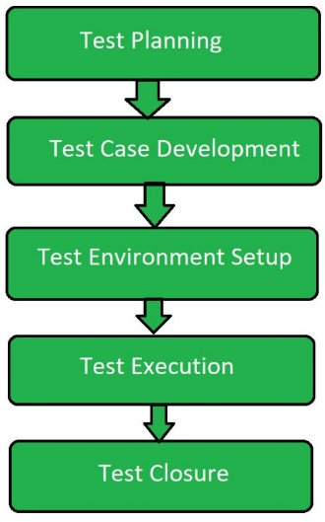 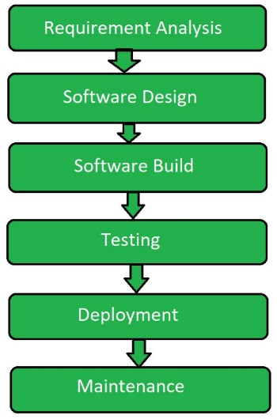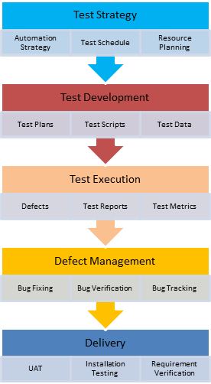

### exit criteria

* Ensuring all critical Test Cases are passed
* Achieving complete Functional Coverage
* Identifying and fixing all the high-priority defects
* Fixing all the ‘Show Stopper defects’ or ‘Blockers’ and ensuring that none of the identified Critical/Severity 1 defects are in Open Status
* Re-testing and closing all the high-priority defects to execute corresponding Regression scenarios successfully

**Entry Criteria:**

* Availability of complete or partially testable code
* Appropriately defined and approved requirements
* Access to sufficient and desired test data
* The readiness of test cases
* Setting up of test environment with all the necessary resources like tools and devices
* Spot checks to ensure all the preconditions are met, and eradicate any defects or tasks that are delaying the process timelines

Python:

**Features of Python?**

* Easy to learn and use
* Expressive language
* Interpreted language
* Cross-platform language
* High level language
* Portable
* Free and open source language
* Object oriented language
* Extensible
* Large standard library
* GUI Programming support
* Integrated
* Embeddable
* Dynamically Typed Language

**What is PEP 8?**

PEP stands for Python Enhancement Proposal. PEP 8 is Python’s style guide. It’s a set of rules for how to write your Python code more readable.

**4. How is Python script executed ?**

When a Python script is executed, it doesn’t convert its code into machine code. **It actually converts it into something called byte code. Execution of Python script means execution of the byte code on the Python Virtual Machine (PVM).**

**What is the difference between .py and .pyc files ?**

.py files are the original text files holding Python code.

.pyc files are the compiled version of the .py files. These are byte code files that is generated by the Python compiler.

Python compiles the .py files and saves it as .pyc files

**What is pickling and unpickling in Python?**

Pickling is a process in which pickle module accepts any Python object and converts it into a string representation and dumps the same into a file by calling the dump method.

**Unpickling:**

Unpickling is a process in which retrieving original Python objects from a stored string representation. Simply, the reverse process of pickling is known as unpickling.

**What are python modules? Name some commonly used built-in modules in Python?**

Python modules are files consisting of Python code. A Python module can define functions, classes and variables. A Python module is a .py file containing runnable code.

**What are the iterators in Python?**

In Python, iterators are used to iterate containers like a list or a group of elements. Iterator implements __itr__ and next() method to iterate the stored elements. In Python, we generally use loops to iterate over the collections (list, tuple).

**What is slicing in Python?**

Slicing is a string operation used to select a range of items from sequence type like list, tuple, and string.

The slice object represents the indices specified by range(start, stop, step). The slice() method allows three parameters ie., start, stop, and step.

start – starting number for the slicing to begin.  
stop – the number which indicates the end of slicing.  
step – the value to increment after each index (default = 1).

Although we can get elements by specifying an index. In Python, a string (say text) begins at index ‘0’, and the nth character stores at ‘n-1’. We can also do reverse indexing using negative numbers. By doing this we can get only single element whereas using slicing we can get a group of elements. It is beneficial and easy to get elements from a range by using slice.

**What is Pass in Python?**

Pass statement is a null operation. Nothing happens when it executes. Pass statement helps to pass the control without an error when we want to create an empty class or function.

Example:  
If(x>100)  
print(“Python Interview Questions”)  
else  
pass

**15. What are the built-in types in Python?**

Common native data types in Python are as follows.

**1. Mutable built-in types:** We can change the content without changing the identity

* Dictionaries
* List
* Sets

**2. Immutable built-in types:** We can’t change the content once it is created

* Strings
* Tuples
* Numbers

**What are *args and **kwargs in Python?**

* In Python, *args and **kwards are used to pass a variable number of arguments to a function using special symbols.
* We use *args and **kwargs as an argument when we aren’t sure how many arguments to pass in the functions.

**What does len() do?**

It is used to determine the length of a string, a list, an array, etc.

a=’STM’  
len(a)

**How you can convert an int to a string?**

Python has a built-in function str() for converting an integer number to string. We need to pass an integer number to this function. It will convert the integer to a string.

num = 10

# check  and print type of num variable

print(type(num))

# convert the num into string

converted_num = str(num)

# check  and print type converted_num variable

print(type(converted_num))

**Programs:**

##### How to find sum of element in an array?

input: arr[] = {1, 2, 3} = 1+2+3

arr=[1,2,3,4,5]  
print (sum(arr))

##### How to find maximum and minimum element in array?

arr=[1,2,3,4,5]  
max=arr[0]  
n= len(arr)  
for i in range(1,n):  
 if arr[i]>max:  
 max=arr[i]  
print("Maximum Element ",max)  
arr=[1,2,3,4,5]  
min=arr[0]  
n= len(arr)  
for i in range(1,n):  
 if arr[i]<min:  
 min=arr[i]  
print("Minimum Element ",min)

##### How to print the Fibonacci series?

n1=0  
n2=1  
print(n1)  
print(n2)  
for i in range(2,10):  
 sum=n1+n2  
 print(sum)  
 n1=n2  
 n2=sum

##### How to find the factorial of a number?

n1=0  
n2=1  
print(n1)  
print(n2)  
for i in range(2,10):  
 sum=n1+n2  
 print(sum)  
 n1=n2  
 n2=sum

##### How to check number is prime or not?

num= 5  
count=0  
if num>1:  
 for i in range(1,num+1):  
 if(num%i)==0:  
 count=count+1  
 if count==2:  
 print("Number is prime")  
 else:  
 print("Number is not prime")

##### How to swap two numbers?

num1= input("Enter num1 value:")  
num2= input("Enter num2 value:")  
print("Value of num1 before swapping: ",num1)  
print("Value of num2 before swapping: ",num2)  
temp=num1  
num1=num2  
num2=temp  
print("Value of num1 after swapping: ",num1)  
print("Value of num2 after swapping: ",num2)

without temp variable

num1.num2=num2, num1  
num1= input("Enter num1 value:")  
num2= input("Enter num2 value:")  
print("Value of num1 before swapping: ",num1)  
print("Value of num2 before swapping: ",num2)  
num1,num2=num2,num1  
print("Value of num1 after swapping: ",num1)  
print("Value of num2 after swapping: ",num2)

##### How to find maximum and minimum element in array?

arr=[1,2,3,4,5]  
max=arr[0]  
n= len(arr)  
for i in range(1,n):  
 if arr[i]>max:  
 max=arr[i]  
print("Maximum Element ",max)  
arr=[1,2,3,4,5]  
min=arr[0]  
n= len(arr)  
for i in range(1,n):  
 if arr[i]<min:  
 min=arr[i]  
print("Minimum Element ",min)

##### How to find the length of a list?

##### How to swap first & last elements of a list

mylist=[11,2,3,4,15]  
size=len(mylist)  
temp= mylist[0]  
mylist[0]=mylist[size-1]  
mylist[size-1]=temp  
print("List after swapping ",mylist)

##### How to remove the nth occurrence/Duplicate of the word from a list?

mylist= ["geeks", "for", "geeks"]  
word="geeks"  
n=2  
count=0  
for i in range(0,len(mylist)):  
 if(mylist[i])==word:  
 count=count+1  
 if(count==n):  
 del mylist[i]  
print("Updated List", mylist)

##### How To Search an Element in a List

mylist=[1,6,3,5,3,4]  
ele=4  
flag=0  
for i in mylist:  
 if(i==ele):  
 print("Element Found")  
 flag= 1  
 break  
if(flag==0):  
 print("Element Not Found")

##### How to clear a List?

mylist= [6,0,4,1]  
print ("My List before clear:",mylist)  
mylist.clear()  
print("My List before clear:",mylist)

**or 4th method** mylist=[]

**2nd method:** mylist*=0

**3rd method:** del mylist[:]

##### How to clone or copy a list?

mylist= [4,8,2,10,15,18]  
mylist_copy=mylist[:]  
print(mylist_copy)

**2nd method:**

mylist= [4,8,2,10,15,18]  
mylist_copy= mylist.copy()  
print(mylist_copy)

##### Program to count the occurrence of an element in a list?

mylist= [15,6,7,10,12,10,20,10]  
x=10  
count=0  
for ele in mylist:  
 if(ele==x):  
 count=count+1  
print("{} has occured {} times".format(x,count))

##### How to find sum of element in the list?

mylist= [5,10,15,20]  
total=0  
for i in range(0,len(mylist)):  
 total=total+mylist[i]  
print ("Sum of all elements in given list: ", total)

##### The difference between the largest and smallest values in the array

lst = [10, 3, 5, 6]  
print(max(lst) - min(lst))

##### How to find the smallest and the largest number in a list?

mylist= [20,100,20,1,10]  
mylist.sort()  
print(mylist)  
print("smallest element is:", mylist[0] )  
print("Largest element is:", mylist[-1] )

mylist= [20,100,20,1,10]  
print("smallest element is:", min(mylist))  
print("Largest element is:", max(mylist))

### What is Accessibility Testing?

Accessibility Testing is defined as a type of Software Testing performed to ensure that the application being tested is usable by people with disabilities like hearing, color blindness, old age and other disadvantaged groups. It is a subset of [Usability Testing](https://www.guru99.com/usability-testing-tutorial.html).

* **Speech RecognitionSoftware –** It will convert the spoken word to text , which serves as input to the computer.
* **Screen reader software** – Used to read out the text that is displayed on the screen
* **Screen Magnification Software**– Used to enlarge the monitor and make reading easy for vision-impaired users.
* **Special keyboard** made for the users for easy typing who have motor control difficulties
* **What is WCAG?**
* The Web Content Accessibility Rules are part of a set of web accessibility guidelines issued by the World Wide Web Consortium's Web Accessibility Initiative, the primary worldwide standards body for the Internet.
* **What Are the Four Major Categories of Accessibility?**
* The Four Major Categories of Accessibility as per WCAG or Web Content Accessibility Guidelines -
* ·         Perceivable - user can comprehend the information
* ·         Operable - user can use, navigate the information
* ·         Understandable - user can Understand the information
* ·         Robust - information is interpreted relia
* **What is accessibility tools?**
* Accessibility tools are applications or agents used by disadvantaged and disabled persons to use an application software which has been tested for accessibility, navigatable and is usable by them.
* Various accessibility tools usually includes
* -          Screen readers for vision and hearing disability
* -          Color scheme changer for color blind persons
* -          Local language selection for low literacy persons
* -          Accessibility plug ins and add-ons for old age and physical disability
* **What is the best tool for accessibility testing?**
* Best Web Accessibility Testing Tools and Solutions #1) WAVE. #2) JAWS. #3) Dynomapper. It also provides content inventory and audit for filtering pages, files, images etc. #4) SortSite. #5) Accessibility Checker by CKSource. #6) Accessibility Valet. #7) EvalAccess 2.0. #8) AChecker –

JAWS: It is the most popular Screen Reader for the customers who have lost their vision

* Some of the good features of JAWS includes two multi-lingual synthesizers Viz. Eloquence and Vocalizer Expressive

Dynomapper: is Visual Sitemap Generator of 4 types Default, Circle, Tree, and Folder

for filtering pages, files, images etc.

### SortSite

* SortSite is a popular one click user experience testing tool for Mac, OS X, and Windows
* Evaluates accessibility of a website against Accessibility standards such as WCAG 2.0 110  checkpoints, WCAG 1.0 85 checkpoints and Section 508 15 US 47 checkpoints
* Compatible with IE, Desktop browser, and Mobile Browser
* Checks for English and French Spellings and custom dictionary for words out of the box
* Checks for HTTP error codes and script errors
* Validates HTML, CSS and XHTML

OOPs:

* Class = A specific car model, such as Audi A4, BMW I8, Maruti Suzuki Vitara Brezza, etc.( It is only a logical component and not the physical entity.)
* Object = A specific car of any model, like the car you own(An object can be defined as an instance of a class, and there can be multiple instances of a class in a program.)
* Characteristics = What is the color of your car? What is the Chassis number of your car? Etc
* Behavior = How to start the car? How to change the gear of the car? Etc

[**Polymorphism**](https://www.geeksforgeeks.org/polymorphism-in-java/) : differentiate between entities with the same name efficiently.

1. [*Overloading*](https://www.geeksforgeeks.org/overloading-in-java/)
2. [*Overriding*](https://www.geeksforgeeks.org/overriding-in-java/)

### Inheritance

It’s creating a parent-child relationship between two classes. It offers robust and natural mechanism for organizing and structure of any software.

### Encapsulation

*T* he variables of a class are always hidden from other classes. It can only be accessed using the methods of their current class. For example – in school, a student cannot exist without a class.

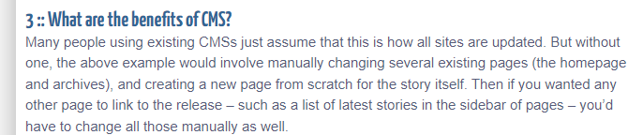

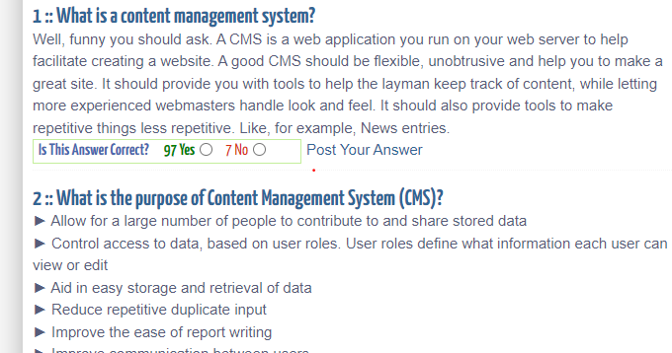

* ... publishes content on a site he is not authorized to
* ... deletes published content from a site
* ... modifies templates without authorization
* ... adds editors and publishers without authorization
* ... modifies the scheduled publishing date for an article
* ... views the list of documents scheduled for publication
* ... steals the passwords of other users